# Alternatives / Competitor Analysis

Competitor being analyzed: Outback Steakhouse (outback.com)

Outback Steakhouse’s website works in a more user friendly and user efficient manner in accomplishing the same tasks that Saltgrass’ website attempts to accomplish in a number of ways. We will analyze Outback’s website in comparison to Saltgrass’ through examining its homepage, its menu page, its call ahead / wait list page, and its career information page.

## Home Page:

Overall, Outback’s homepage is less busy and more refined in appearance than Saltgrass’. Its color scheme follows the 60-30-10 rule that is recommended for good website layout design (ADD ANOTATION). Additionally, the homepage’s navigation bar’s font size is large and easily readable, with each navigation option offering helpful and descriptive text detailing where each option leads to. Finally, although this page has a slider (which is not necessarily recommended for good design), the slider itself has a small number of pictures that moves slowly through each one, while each image itself follows the same color scheme as the site and contains pertinent information to the user. Finally, the homepage is not cluttered with advertisements and sponsors, thus improving the look of the website and keeping unneeded information out of the user’s field of view. All of this can be seen through viewing **Figure 2.1**.

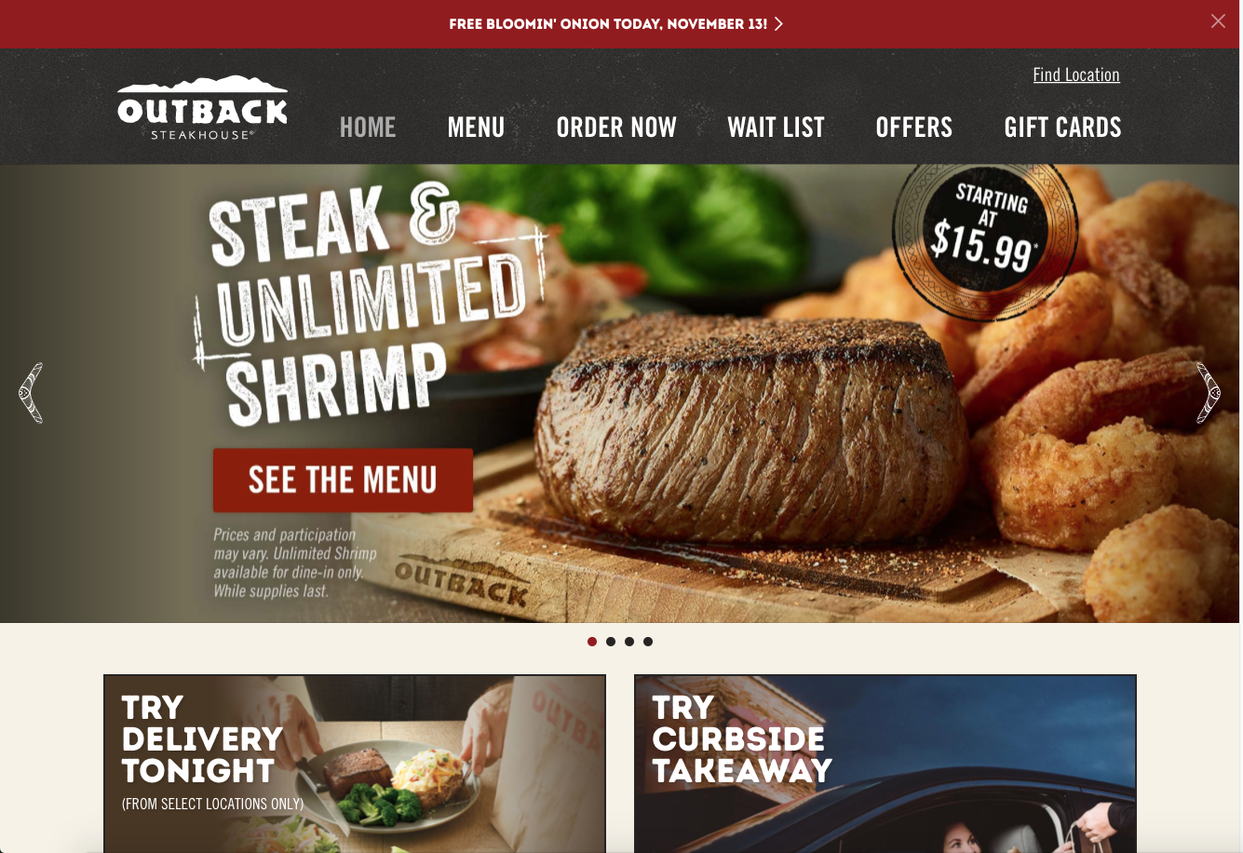

Large navigation bar

Few items in slider, and slider moves slowly

Figure .1: Home page isn’t overly busy, and color scheme roughly follows 60-30-10 rule. Navigation bar is large and informative, and slider is slow moving with few images.

## Menu:

If we navigate as user Jane Doe would, we would attempt to locate the menu for Outback to view food items and pricing. The menu on this site is very easily accessible as it is one of the main navigation options located on the navigation var. Clicking on the menu navigation option shows us the menu directly, and does not redirect us to another site or require us to download a PDF of the menu to view. Additionally, the menu is not location specific, and navigating the menu itself is easy due to the large navigation text within the various menus offered. This reduces the total number of clicks needed by the user, thus improving overall usability and friendliness. All of this can be seen in **Figure 2.2.**

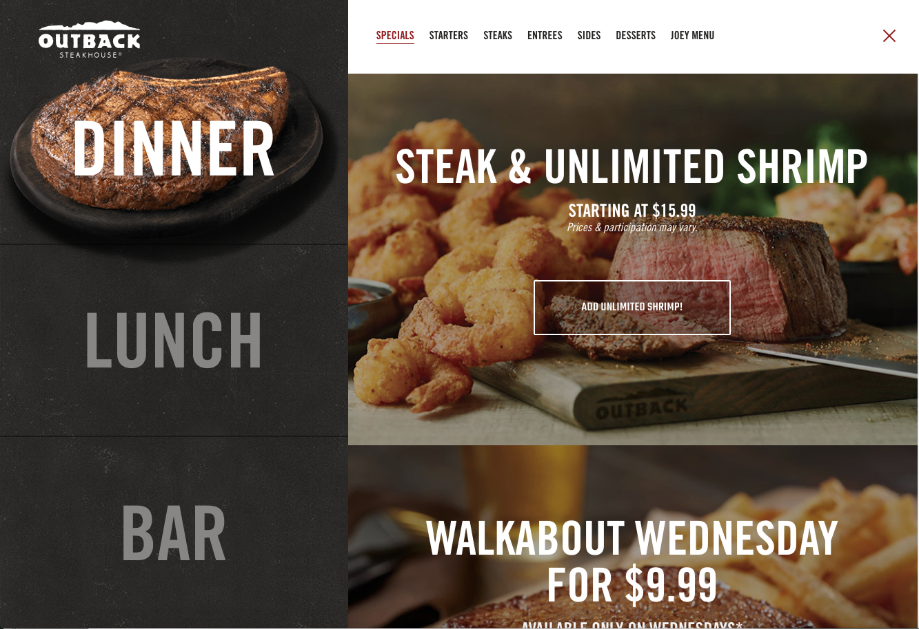

Easily navigable and informative menu headings

Menu is native to website, with large navigation buttons

Figure 2.2: The menu available on Outback Steakhouse’s website is easily navigable, shows prices and menu items clearly, and is native to the original website (doesn’t require redirection to another site / downloading a PDF)

## Call Ahead / Wait List:

Finding call ahead and wait list information for a specific Outback location, something that user John Smith would attempt to do, is easy and intuitive on Outback’s site. One of the main navigation options on the navigation bar is labeled “Wait List”, and clicking on this option leads us to the call ahead / wait list page. This page has very little unnecessary text and is uncluttered. A text box prompts user to enter the zip code they are in, and then displays Outback’s that are local to that zip code. This is a much more intuitive way of searching for specific information than a drop-down menu. Contact information is displayed clearly after specifying a zip code, and a map is displayed next to the listed contact information for a more exact location description. Finally, these features are native to Outback’s site, and do not require any redirections or downloads. All of this can be seen in **Figure 2.3.**

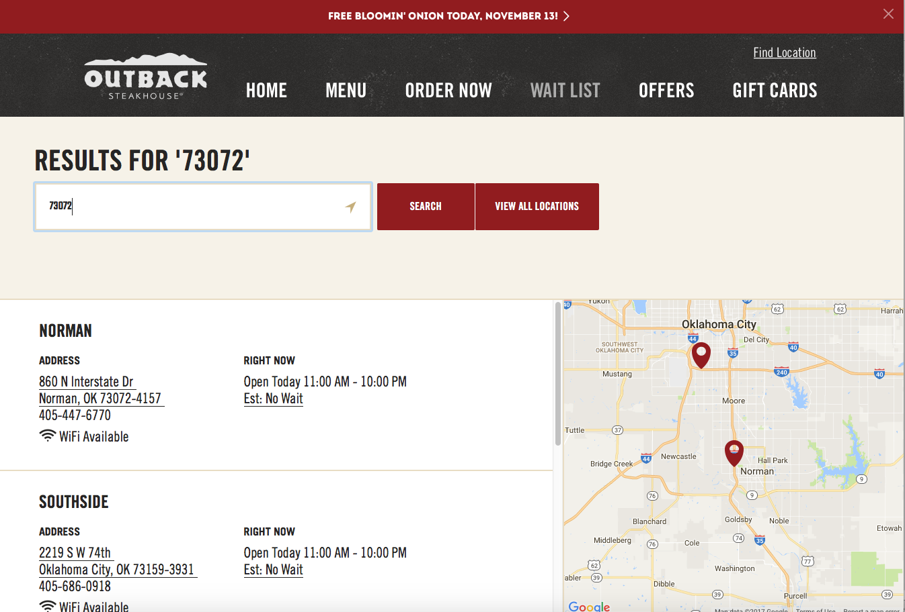

Search for specific zip code, rather than a drop down

Contact info and address easily viewable

Map available showing exact location

Figure 2.3: Searching for call ahead information is easily done on Outback’s website through their “Wait List” page.

## Career Information:

If we navigate like user Ron Swanson would, we would attempt to find information about available positions at outback as well as information on how to apply. Obtaining this information on Outback’s site is native to the site itself, and can be found by clicking on the “Careers” navigation option. This page allows us to search for job openings based off a number of different criteria that can be selected through different drop-down menus that are large and clearly visible. When we select a specific position, the page does redirect us to the restaurants parent site for application information, but this is only done after finding available openings for specified positions, rather than when clicking on the “Careers” navigation option. All of this can be seen in **Figure 2.4.**

# Proposal

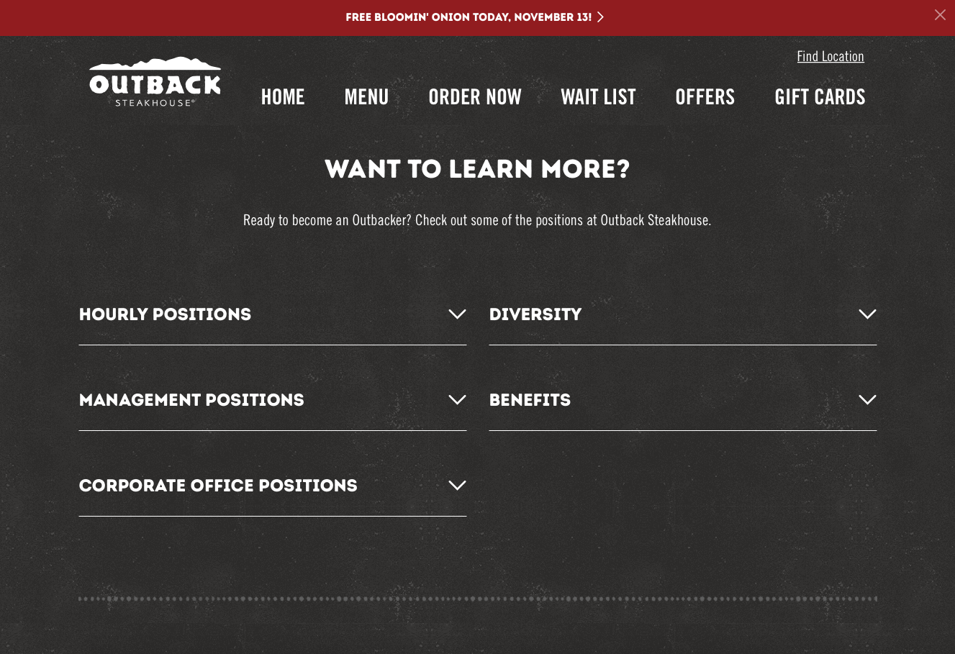

Career search through position & location

Native to outback.com

Figure 2.4: Finding career information is native to ouback.com, and searchable by position and location.

In conclusion, we recommend that you allow us to run a usability test for your website. This test will involve asking participants who have never used your website before to perform basic functions and / or search for specific information on your site. This test will be in a controlled environment, and all information from the test will be observed from a member of our team to determine pain points and areas for improvement for your site

Since a large part of your site’s traffic will be searching for a menu to view food items and pricing, call ahead for seating, and gaining information on applying for a server position at Saltgrass, a majority of this usability test will be focused on completing objectives involving these three areas. We will ask users to perform the following tasks:

* Navigate to a dinner menu from the home page, and find the price of a cheeseburger.
* Navigate to a page containing contact information for the Norman, Oklahoma Saltgrass location.
* Navigate to the applications page for a server at Saltgrass

We will use the following quantitative data to measure the overall usability of your site:

* Total time for completing each task
* Total number of clicks it takes to complete a task
* Total number of misdirections (navigating to an area of the site which does not contain information leading to or information pertaining to the completion of a task)

Upon completing this usability test, we will report back to you on our findings with this quantitative information, and work with you on possible solutions for your site if you so choose.